**PROJECT REPORT**

INTELLIGENT CUSTOMER HELP

DESK WITH SMART DOCUMENT UNDERSTANDING

**Name: Rosia Sony**

**Email: rosiasony2000@gmail.com**

**Category: Artificial Intelligence**

**INDEX**

1. **INTRODUCTION**
   1. Overview
   2. Purpose
2. **LITERATURE SURVEY**
   1. Existing problem
   2. Proposed solution
3. **THEORITICAL ANALYSIS**
   1. Block diagram
   2. Hardware / Software designing
4. **EXPERIMENTAL INVESTIGATIONS**
5. **FLOWCHART**
6. **RESULT**
7. **ADVANTAGES & DISADVANTAGES**
8. **APPLICATIONS**
9. **CONCLUSION**
10. **FUTURE SCOPE**
11. **BIBILOGRAPHY**

|  |  |
| --- | --- |
|  |  |
|  | | |
|  | |
|  | |
|  | |
|  | |
|  | |

|  |  |  |  |  |  |
| --- | --- | --- | --- | --- | --- |
|  |  |  |  |  |  |

INTRODUCTION

* 1. **Overview**

We will build a chatbot that uses various Watson AI Services (Watson Discovery,

Watson Assistant, Watson Cloud Functions and Node-Red) to deliver an effective Web based UI through which we can chat with the assistant. We will integrate the Watson Discovery service with Watson Assistant using webhooks.

* + 1. ● Project Requirements : Node-RED, IBM Cloud, IBM Watson, Node JS
  1. ● Functional Requirements : IBM Cloud
  2. ● Technical Requirements : AI, ML, Watson AI, Node JS

● Software Requirements : Watson Assistant, Watson Discovery, Watson Cloud Functions, Node-RED

* 1. ● Project Deliverables : Intelligent Chatbot with Smart Document Understanding
  2. ● Project Team : Rosia Sony
  3. ● Project Duration : 29 Days

1.**2 PURPOSE**

The typical customer care Chabot can answer simple questions, such as store locations and hours, directions, and maybe even making appointments. When a question falls outside of the scope of the pre-determined question set, the option is typically to tell the customer the question isn’t valid or offer to speak to a real person.

In this project, there will be another option. If the customer question is about the operation of a device, the application shall pass the question onto Watson Discovery Service, which has been pre-loaded with the device’s owner’s manual. So now, instead of “Would you like to speak to a customer representative?” we can return relevant sections of the owner’s manual to help solve our customers’ problems.

To take it a step further, the project shall use the Smart Document Understanding feature of Watson Discovery to train it on what text in the owner’s manual is important and what is not. This will improve the answers returned from the queries.

1. literature survey
   1. **Existing problem**

As we all know that the catalogue and owner’s manuals of various products and companies are not actually needed by all the customers .So to make the task easy for the customers and to find the answers quickly the chatbots can be introduced.

* 1. **Proposed Solution**

Here we are going to develop a smart chatbot which will answer mostly all of the customer related queries. If the customer question is about the operation of a device, the application shall pass the question onto Watson Discovery Service, which has been pre-loaded with the device’s owner’s manual. We can return relevant sections of the owner’s manual to help solve our customers’ problems.

To take it a step further, the project shall use the Smart Document Understanding feature of Watson Discovery to train it on what text in the owner’s manual is important and what is not. This will improve the answers returned from the queries. Then using Watson actions as webhook, Watson Discovery can be integrated with Watson assistant. Finally using Node-Red, Watson assistant can be integrated with a web UI. This UI can then be used to connect with Watson assistant and chat with it. And also it can work for 24 hours which a normal human being cannot.

**3. Theoretical Analysis**

* 1. **3.1 Block / Flow Diagram**



**3.2 Hardware /Software Designing**

1. Create necessary Watson Services.

2. Configure Watson Discovery.

3. Create Watson Cloud Functions Action.

4. Configure Watson Assistant.

5. Integrate Watson Discovery with Watson Assistant using webhook.

6. Build Node-RED flow to integrate Watson Assistant and Web Dashboard.

**4. Experimental Investigation**

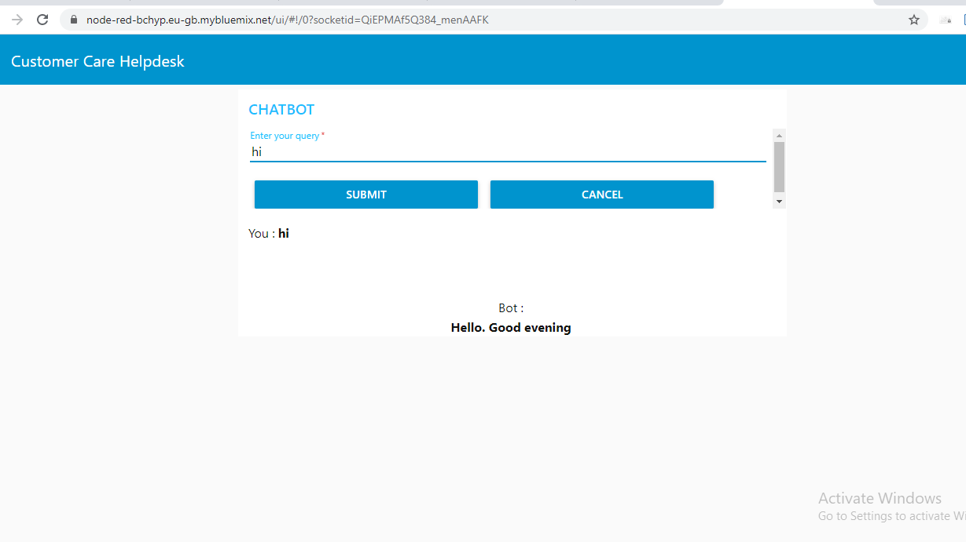

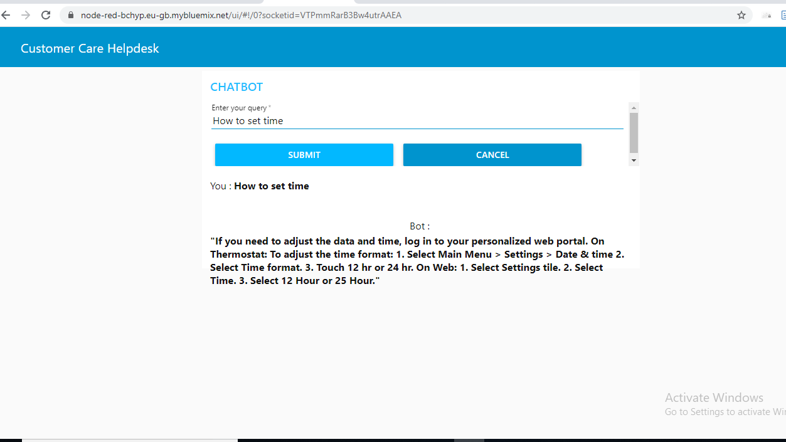

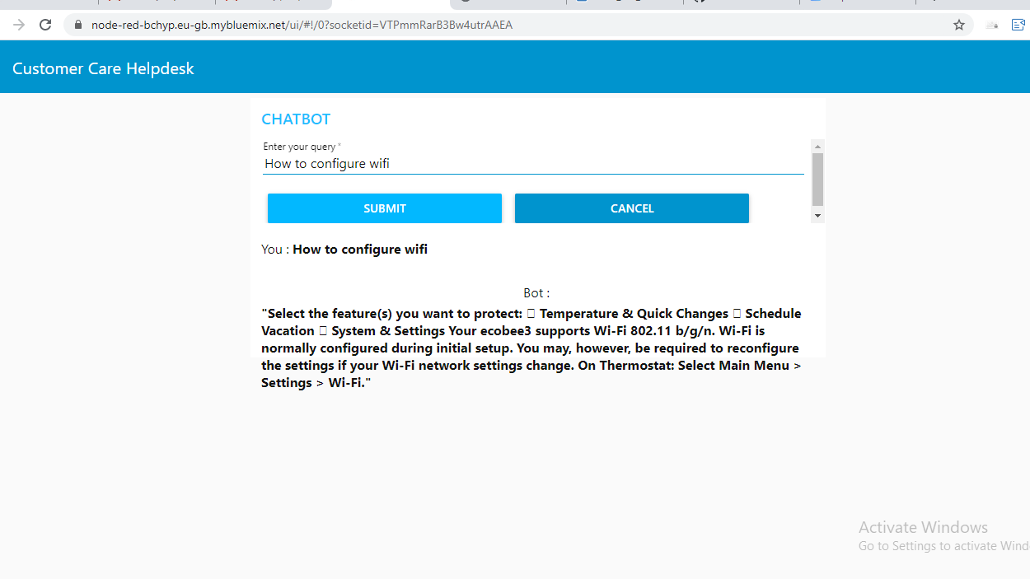

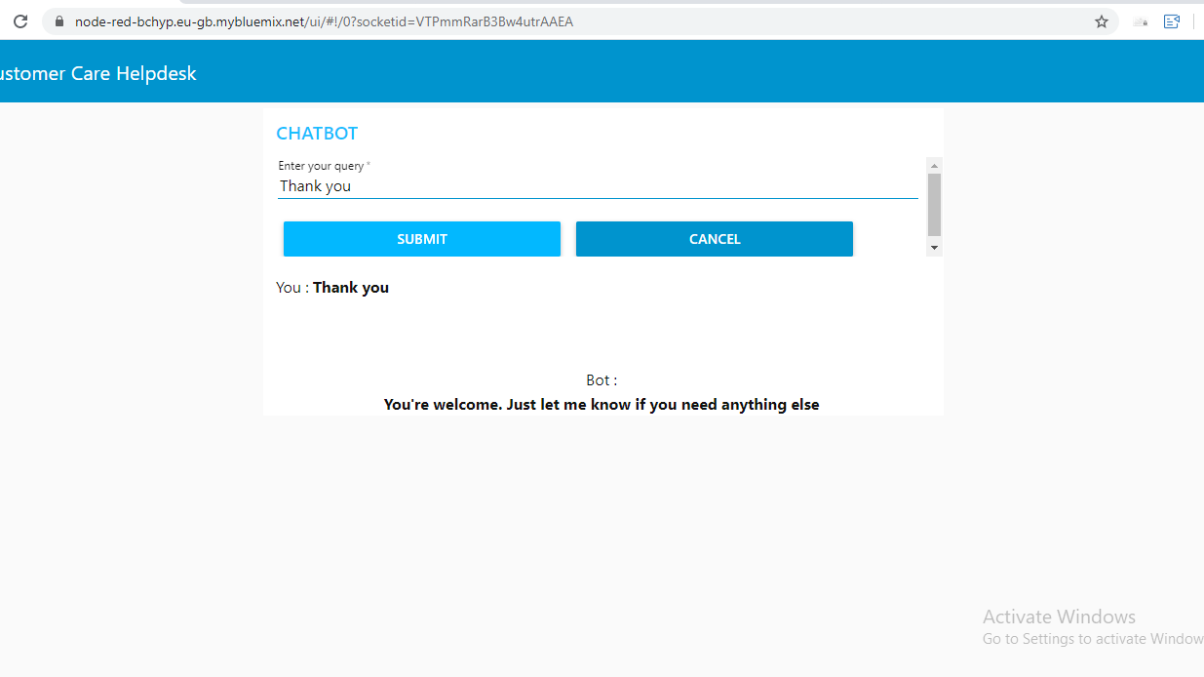

**5. Flowchart**

Insert the following nodes into the flow in Node-RED.

● Debug

● Ui_Form

● Ui_Text

● Function

● Assistant

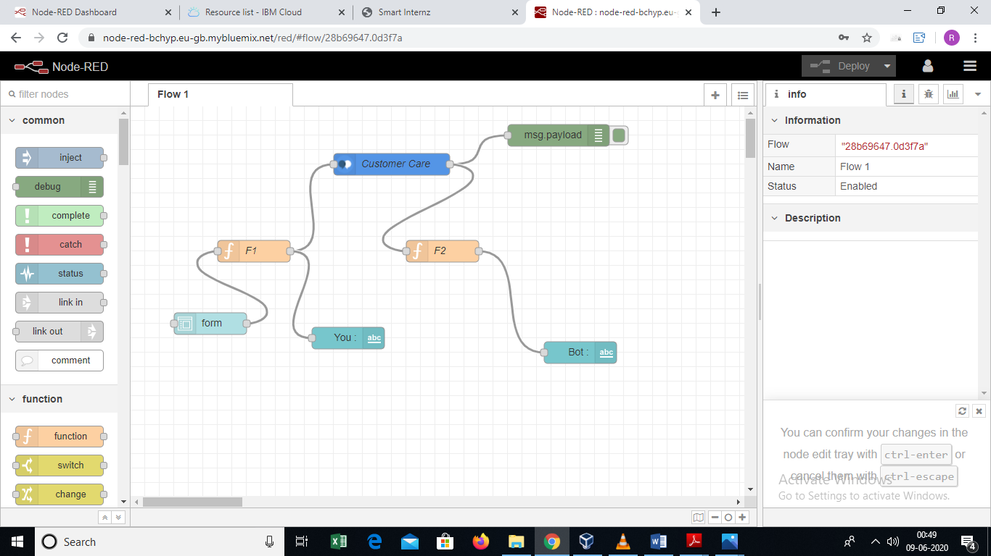

**6. Result**

Web based UI was developed by integrating all the services using NODE-RED

URL for UI Dashboard <https://node-red-bchyp.eu-gb.mybluemix.net/ui/>

**7. Advantages & Disadvantages**

**Advantages :**

1. Reduces Man Power

2. Instantaneous response without the need for human response delays.

3. This type of application is better than the user manuals

4. Quick learning and updating

5. Management of multiple clients

6. Cost Efficient

**Disadvantages :**

1. Sometimes it can mislead customers as it tries to search irrelevant information in the manual.

2. It may also give same answers to different queries.

3. If data is not trained properly then the result will not be accurate

4. Lack Emotions.

5. Bad memory: Can’t memorize the conversation it already had which forces the user to write the same thing again and again.

**8. Application**

* Chatbot can be applied in various fields to help the customer in finding the result in larger documents.
* Chatbot can deploy any website to clarify basic doubts of viewers.
* It can be used to deploy as Customer Helpdesk for small scale products as their manual usually has the solution for the user's problems.
* The primary function of the chatbot is to be a virtual companion – To speak with senior people on general topics like the weather, nature, hobbies, movies, music, news etc.

**9. Conclusion**

An Intelligent Customer Helpdesk Chatbot was created successfully using various Watson services like Watson Discovery, Watson Assistant, Watson Cloud Functions and Node-RED.

**10. Future Scope**

* In the future, various other Watson services like Text-To-Speech and Speech-To-Text can be integrated in the chatbot. This can make the chatbot Hands-free.
* Voice recognition can be added with the virtual assistant. Then the customer can control application by using his voice.
* Smarter Virtual Assistants: Much of the virtual assistants do now are basic skills ,such as retrieving data and basic computation .As natural language processing (NLP) continues to mature, virtual assistants will improve their comprehension and response capabilities, allowing for their use to become more widespread and complex. Also, as machine learning progresses, we may see virtual assistants become smarter and begin to learn and predict customer needs.
* Integration of IoT Devices: Car speakers, smart home devices and wearables are just a few examples where the virtual assistant is departing from its original hardware and making its way to in-context devices. These integrations ensure that virtual assistants can always be near their human and ready to support any need. It is expected that these integrations will continue at an accelerated pace throughout 2018.

|  |  |  |
| --- | --- | --- |
|  |  |  |

**11. Bibliography**

Node Red starter Application:

<https://developer.ibm.com/tutorials/how-to-create-a-node-red-starter-application/>

Build Your Own AI Assistant:

<https://www.youtube.com/watch?v=hitUOFNne14>

How to use Watson Assistant with webhooks:

<https://www.youtube.com/embed/5z3i5IsBVnk>

Watson Discovery:

<https://developer.ibm.com/articles/introduction-watson-discovery/>